* Q1:

VD: play (v)/on (prep)



* A girl is playing the violin on the sofa.
* Q2:

VD: walk (v)/ backpack (n) balô



* A woman is walking and carrying the backpack. (ĐÁ)
* To carry / wear a backpack.
* The woman is walking with her backpack.
* Q3:

VD: exam (n)/ in order to (liên từ)



* A girl is studying very hard in order to get a good score in the exam.
* A girl (on the sofa) is studying very hard in order to pass her exam.
* Q4:

VD: ladder (n) / wall (n)

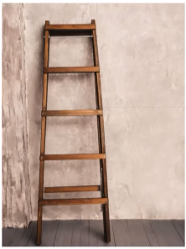

* The wooden ladder is leaning against the wall.
* Q5:

VD: woman (n) / next to (prep)

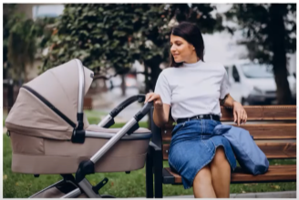

* A woman is sitting next to a baby stroller.

A woman sitting on the bench is looking at a baby next to her.

* Q6:

VD:

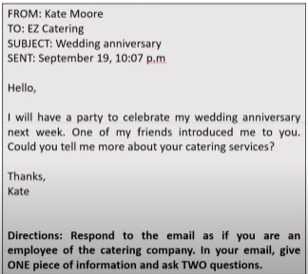

+ Đáp án:

Dear Ms Moore,

Thank you for your interest in our catering services. My name is Rony and I am an employee at EZ Catering. I am writing in response to your email dated September 19th regarding your wedding aniversary next week.

In the last 5 years, we have been the main caterer of many events in the area. Currently, we are offering full service for all types of events. To help us better understand your needs, could you please let me know the estimated number of guests? In addition, what is your budget for this party?

I’m looking forward to hearing from you.

Best regards,

Rony

* Q7:

VD: (văn mẫu đặt phòng)

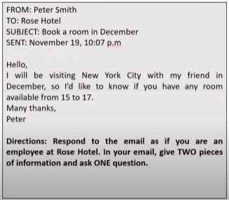

Dear Mr.Smith,

Thank you for your interest in our hotel.

My name is Rony and I am an employee at Rose Hotel. I am writing in response to your email dated November 19th regarding your booking in December.

I would like to let you know that we still have rooms available from 15th to 17th December. Currently, we offer two types of room: standard and superior. Which one do you prefer?

I’m looking forward to hearing from you.

Best regards,

Rony

* Q8:

VD:

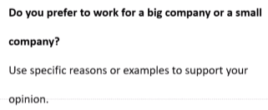

* Answer:

**Introduction:**

When choosing a company to work for, one of the most important factors that a person needs to consider is its size. **Personally, I prefer to** work for a big company and **there are several reasons to support my opinion**.

Body: (Lên ý tưởng)

* Higher salaries (body 1)
* Structured (body 2)
* Mor opportunities to grow (body 3)

**Body 1: (Higher salaries)**

First of all, big companies usually offer higher salaries and lots of perks. Because they have been in the market for a long time, they tend to dominate it and make more profit than small businesses. Therefore, big companies are able to pay their employees more. In addition, these companies have enough resources to provide benefits such as medical insurance and retirement plans.

**Body 2: (have a more structured environment)**

Second, big companies usually have more order and structure. They have tested and found out the best way to run a successful business. Then, they divide it into smaller steps and assign them to employees. Therefore, when working for big companies, people always know their tasks and responsibilities clearly. Let me tell you my sister’s story. Five years ago, after graduating from college, she worked for a small company. Although she was an accountant, she had to take on tasks which were related to sales and marketing. This frustrated her. After 3 months, she quit and she swore never to work for a small company again.

**Body 3: (more opportunities to grow)**

Last but not least, I will have more opportunities to grow. Big companies often attract the best people. Therefore, I will have a chance to work with and learn from people who are experts in their field. Furthermore, big companies usually have training programs which help me sharpen my professional skills. All of these will benefit me greatly, whether I choose to stay with my company or move to another one.

**Conclusion:**

In conclusion, **I prefer to** work for a big company **for the above reasons**. **I think people should** choose the type of company **which suits** / which is right for them and their career.

New words:

sit in a chair: ngồi lọt thỏm vào ghế (ghế có

tay cầm)

sit on a chair: (ghế không có tay cầm)

sit on a sofa

leaning against: tựa lưng, dựa vào tường

leaning: nghiêng

lean on: dựa vào bề mặt

baby stroller: xe đẩy em bé

To carry / wear a backpack: Đeo balo

perks: phúc lợi cho nhân viên = benefits

market: thị trường

tend to: có xu hướng

dominate: thống trị

to make profit: kiếm lợi nhuận.

medical insurance: giải pháp y tế

retirement plans: kế hoạch nghỉ hưu

to divide A into B: chia A thành nhiều cái B

to assign STH to SB: Giao nhiệm vụ cho thành

viên nhóm

frustrated làm bực bội.

i swear never to V: thế không bao giờ làm gì

have more opportunities to do STH: có cơ hội để

làm gì

expert: chuyên gia

to suit + SB = to be suitable for SB